From the Desk of Chairman

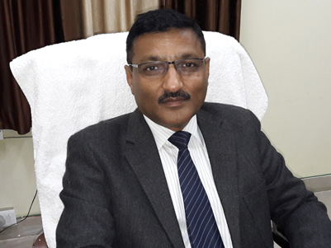

While initiating RIT under Aditya Charitable Trust, the well thought anchor points were of shaping citizenship character, value driven knowledge sharing, an Institution with fundamentals and establishing futuristic learning.   
While encompassing the traditional thoughts some tangible outcomes were also knitted with the fundamentals:-  
  • Employability through futuristic leaning & Industry integrated approach   
  • Opportunities to develop entrepreneurial initiatives, leadership, self-learning and teamwork skills and sense of responsibility towards society   
  
With futuristic approach in professional education and Industrial alliances, we expect RIT to be Academic Leader in its area of educational program and RITians to be Leader of their profession.  
**Atul Bansal**